**COMPANY CERTIFICATE**

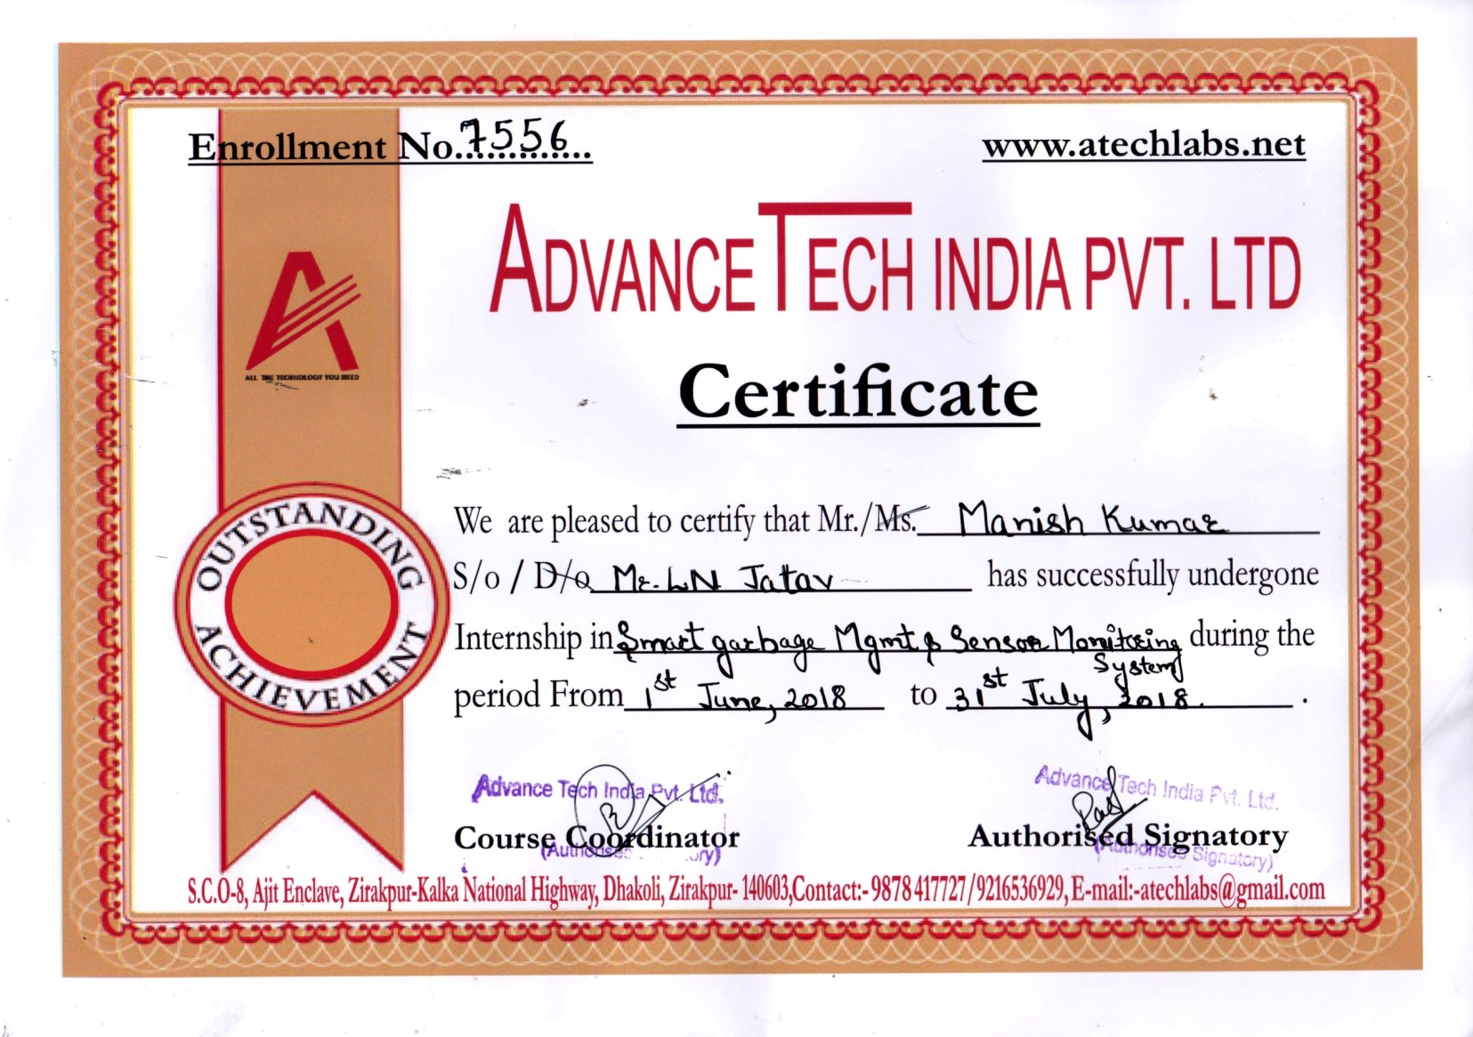

**ACKNOWLEDGEMENT**

I wish to express my sincere gratitude to **Dr. Sachin Chawla (DEAN)** and **Er. Gaurav Sharma (HOD)** of ECE department for their guidance moral boosting, continuous encouragement and appreciation.

I greatly appreciate the motivation and understanding extended for the project work by my instructor Miss Diksha Prajapati, who responded promptly and enthusiastically to my request for frank comments despite their congested schedule. I am indebted to all of them who did their best to bring improvement through their suggestions and giving me guidance to present a report. It helped us a lot to realize of what we study for.

I have immense pleasure in successful completion of the work title. The special environment at GNI, mullana that always supports educational activities, facilitated my work on this project. I acknowledge the support, the encouragement extended for this study by our **faculty member of Electronics And Communication Engineering Department.**

I am thankful to **Adavance Tech Pvt. Ltd.** for giving such a great contribution in my technical training.

I am also thankful to my college library staff and my administrative staff of GNIT institutions, who directly or indirectly have been helpful in some or other wayI wish to express my sincere gratitude to the whole Advance Tech team for providing me an opportunity to learn the embedded systems and internet of things and helping me in completing my projects.

**Manish Kumar**

**(6315221)**

**COMPANY PROFILE**



AdvanceTech India Pvt Ltd an Embedded Design House. AdvanceTech India Pvt Ltd offer various Technical Education solutions, Products & Development tools to Engineering colleges, Universities, research organizations. We also offer the business of providing Technical education solutions & development tools to the educational & industrial customers.Advance Technology has developed a number for private as well government organizations**.**

**AdvanceTech Development :**

AdvanceTech India Pvt Ltd an Embedded Design House. Advance Technology offer various Technical Education solutions, Products & Development tools to Engineering colleges, Universities, research organizations. We also offer the business of providing Technical education solutions & development tools to the educational & industrial customers. AdvanceTech India Pvt Ltd has developed a number for private as well government organizations

**AdvanceTech Industrial Automation :**

AdvanceTech India Pvt Ltd offers all Advance Electronics Security related Products, Services, and Applications with a team of Design, Application and Sales Engineers. We understand the requirement and offers complete Solutions for Colleges/Corporate/Home etc.

**AdvanceTech Education :**

AdvanceTech India Pvt Ltd education mainly deals in Engineers Training Programs in latest technologies for Engineering students, corporate and other professionals. Some of the technologies offered for training are Embedded Systems, VHDL, Advance Embedded Systems, Verilog HDL, Linux, PCB & Circuit Designing and PLC & Industrial Automation.

**ABSTRACT**

This project aims at using the most preffered technology in the embedded sytems industry all over the world i.e. Arduino, which can easily bring life to any of your idea.

* **IOT Based Sensor Monitoring System :** A system consisting nodes with various sensors connected to each node which monitors and sends their data over the cloud
* **Smart Garbage Monitoring System :** A system consisting of bins which have various sensors embedded in them and monitors the waste and sends the data over the cloud and to the control authorities
* **Wireless Controlled DMD Panel :** A system which consist a dot matrix panel which is connected to a arduino board which and is controlled wirelessly via bluetooth

**Technology Used :**

* **Hardware :** A microcontroller is a compact integrated circuit designed to govern a specific operation in an embedded system. A typical microcontroller includes a processor, memory and input/output (I/O) peripherals on a single chip. Microcontrollers in this projects are Arduino UNO Board and a NODE MCU ESP8266 Board and some of the sensors.
* **Software :** The open-source Arduino Software (IDE) makes it easy to write code and upload it to the board. It runs on Windows, Mac OS X, and Linux. The environment is written in Java and based on Processing and other open-source software.

CloudMQTT is the cloud service which is used in the project. Cloud MQTT are managed Mosquitto servers in the cloud. Mosquitto implements the MQ Telemetry Transport protocol, MQTT, which provides lightweight methods of carrying out messaging using a publish/subscribe message queueing model. MQTT is the machine-to-machine protocol of the future. It is ideal for the “Internet of Things” world of connected devices. Its minimal design makes it perfect for built-in systems, mobile phones and other memory and bandwidth sensitive applications.

**LIST OF FIGURES**

| **Figures** | **Title** | **Page No.** |
| --- | --- | --- |
| Figure 1.1 | Internet Of Things | 3 |
| Figure 1.2 | Future Of IoT | 5 |
| Figure 2.1 | Microcontroller | 6 |
| Figure 2.2 | Block Diagram Of A Microcontroller | 7 |
| Figure 3.1 | Arduino UNO Pin Config | 8 |
| Figure 3.2 | NODE MCU ESP8266 Pin Config | 9 |
| Figure 3.3 | IR Sensor | 10 |
| Figure 3.4 | Magnetic Sensor | 11 |
| Figure 3.5 | 16 X 2LCD Module | 12 |
| Figure 3.6 | Buzzer | 12 |
| Figure 3.7 | Arduino IDE | 13 |
| Figure 3.8 | Cloud MQTT | 14 |
| Figure 4.1 | Garbage Bins | 15 |
| Figure 4.2 | Status Of Bins | 16 |
| Figure 4.3 | Block Diagram of the System (a) | 16 |
| Figure 4.4 | Block Diagram of the System (b) | 17 |
| Figure 5.1 | Bin 1 | 20 |
| Figure 5.2 | Bin 2 | 20 |
| Figure 5.3 | System | 21 |
| Figure 5.4 | Arduino IDE (Program) | 21 |
| Figure 5.5 | Cloud MQTT (Cloud Status) | 22 |
|  |  |  |

**LIST OF TABLES**

| **Tables** | **Title** | **Page No.** |
| --- | --- | --- |
| Table 1 | Connection Diagram (a) | 18 |
| Table 2 | Connection Diagram (b) | 18 |
|  |  |  |
|  |  |  |
|  |  |  |
|  |  |  |
|  |  |  |
|  |  |  |
|  |  |  |
|  |  |  |